**OS X SDK Integration Guide**

Before you start, you should [Login](http://www.desktopad.com) desktopad.com and apply for an application.

Step 1: Download the OS X SDK from [Github](https://github.com/desktopadsdk/DesktopAD-SDK-For-OSX).

Step 2: Drag-and-drop the SDK folder to your project:

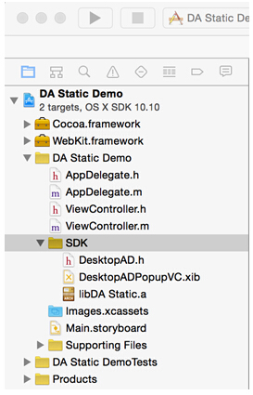

Step 3:  Add WebKit.framework Within the 'Link Binary with Libraries' section, opened through the path: Target->Build Phases->Link Binary With Libraries. Picture below:

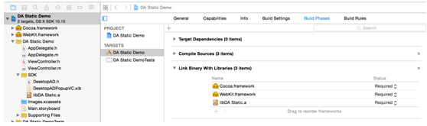

Step 4: Add the code to your appdelegate.m file:

-(void)applicationDidFinishLaunching:(NSNotification *)aNotification {

// Insert code here to initialize your application

[DesktopAD setAppKey:@"Your Appkey" appSecret:@"Your Appsecret"];

}

PS: Each application has its unique key and secret. You can get a pair of them in your user center after applying for a new application.

Step 5: If you want to show banner ad, you can do like this:

NSView *ad_portrait = [DesktopAD bannerAd_Portrait];

[ad_portrait setFrame:CGRectMake(100, 100, ad_portrait.frame.size.width, ad_portrait.frame.size.height)];

[self.view addSubview:ad_portrait];

NSView *ad_landscape = [DesktopAD bannerAd_Landscape];

[ad_landscape setFrame:CGRectMake(300, 100, ad_landscape.frame.size.width, ad_landscape.frame.size.height)];

[self.view addSubview:ad_landscape];

NSView *ad_halflandscape = [DesktopAD halfBannerAd_Landscape];

[ad_halflandscape setFrame:CGRectMake(300, 200, ad_halflandscape.frame.size.width, ad_halflandscape.frame.size.height)];

[self.view addSubview:ad_halflandscape];

Step 6: If you want to show a popup ad, you can use the method:

[DesktopAD showPopupAd];

You can finde a demo in the folder, you should replace “Your appkey” and “Your appsecret” with your real appkey&appsecret.

**Before you submit your application for review, please make sure that your application can display the test ads like this:**

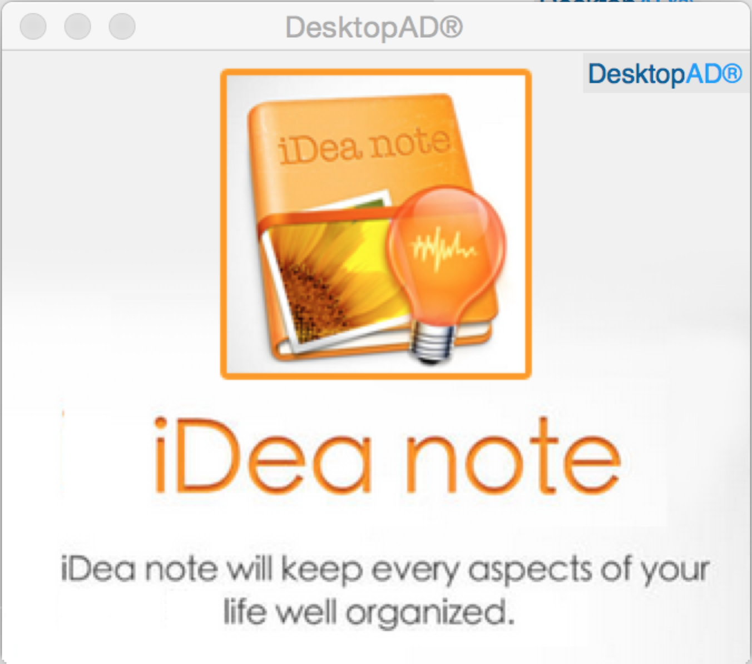

If you have any questions, please contact us: [service@desktopad.com](mailto:service@desktopad.com) .